Ex 4:

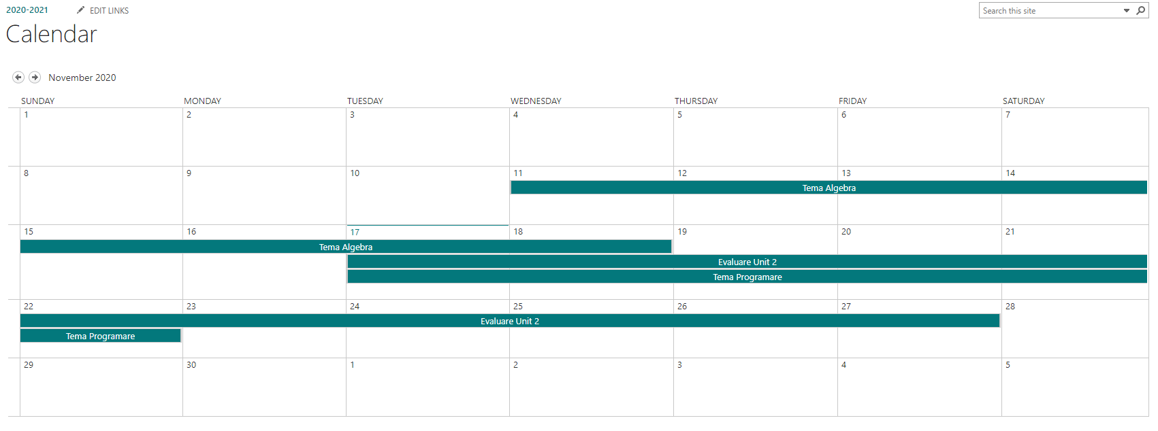

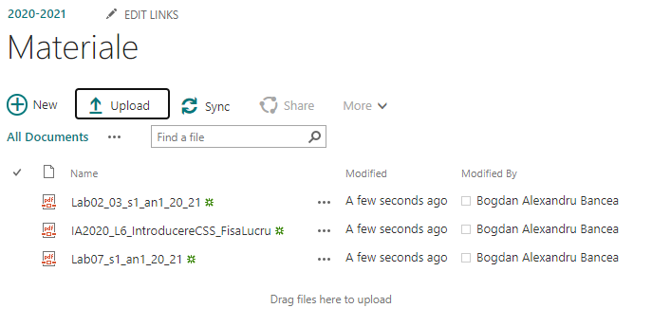

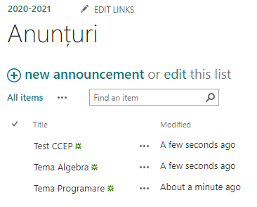

|  |  |  |
| --- | --- | --- |
| Denumire Lista | Denumire Coloana | Tip coloana |
| Calendar | Laborator | Lista |
| Materiale | Disciplina | Lista |
| Anunturi | Perioada | Data & Timp |